# Assignment 1:

Ans) Time complexity is O(n2).

For inner loop it will be O(n)

And for the outer loop it’ll be O(n)

So overall it is O(n2).

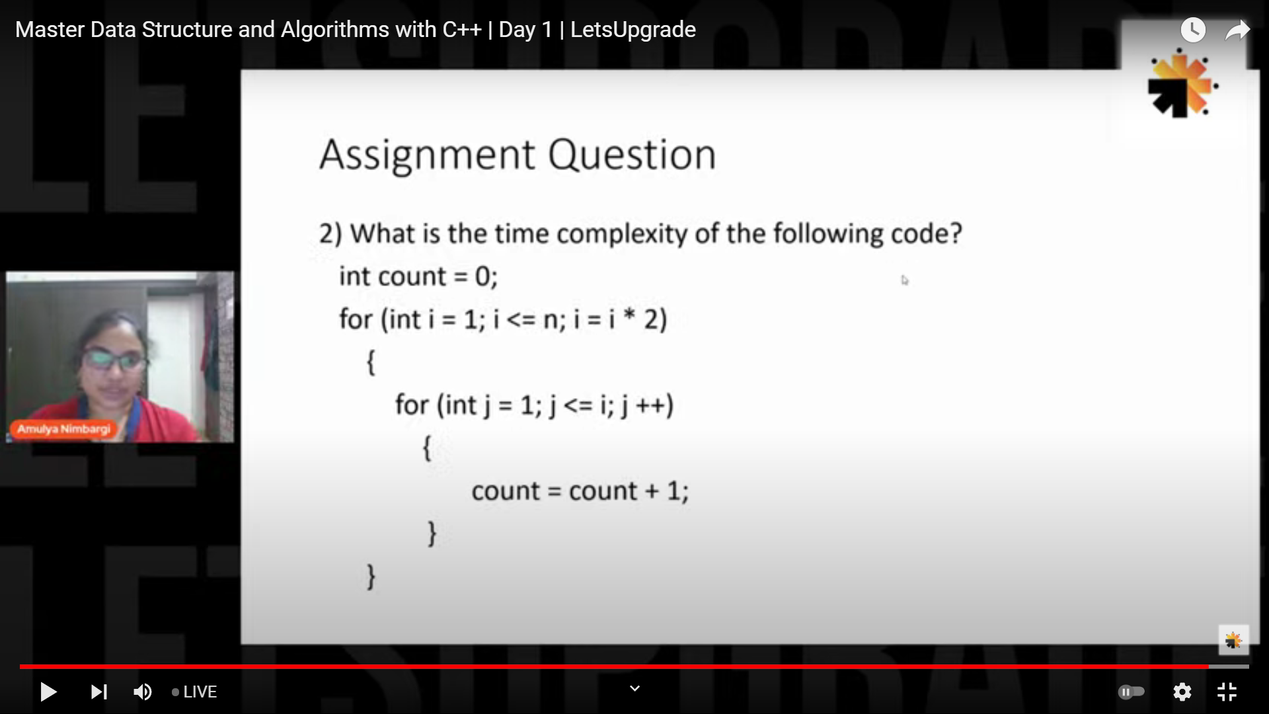

Ans)

Time complexity:O(n log n)

For inner it’ll be O(n)

For outer it’ll be O(log n)

So overall it’ll be

O(n log n)

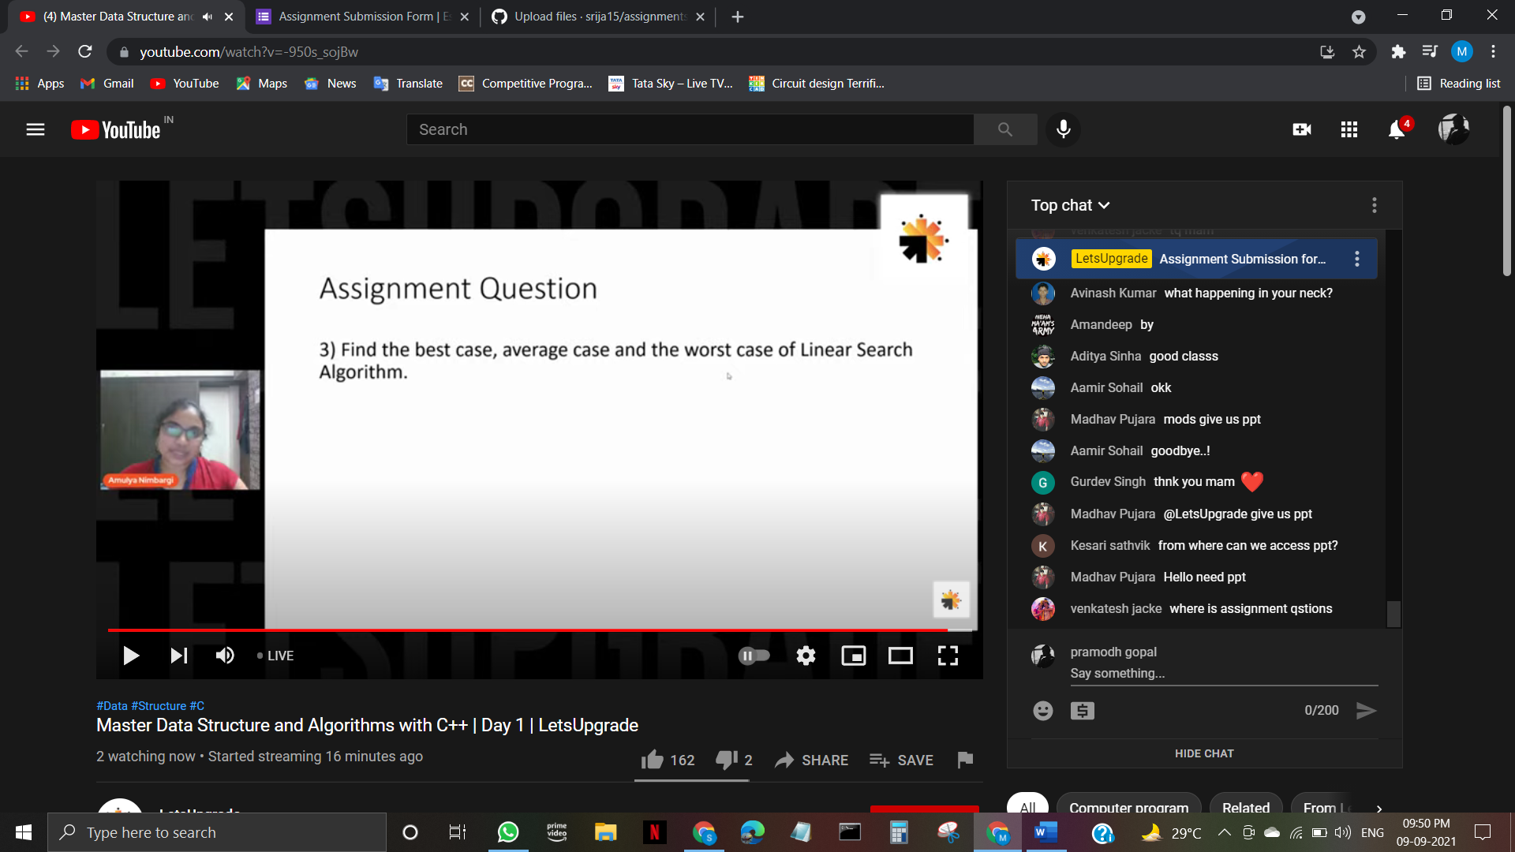

Ans) Linear search

Best case complexity is O(1)

Worst case complexity is O(n)

Average casee complexity is O(n/2)